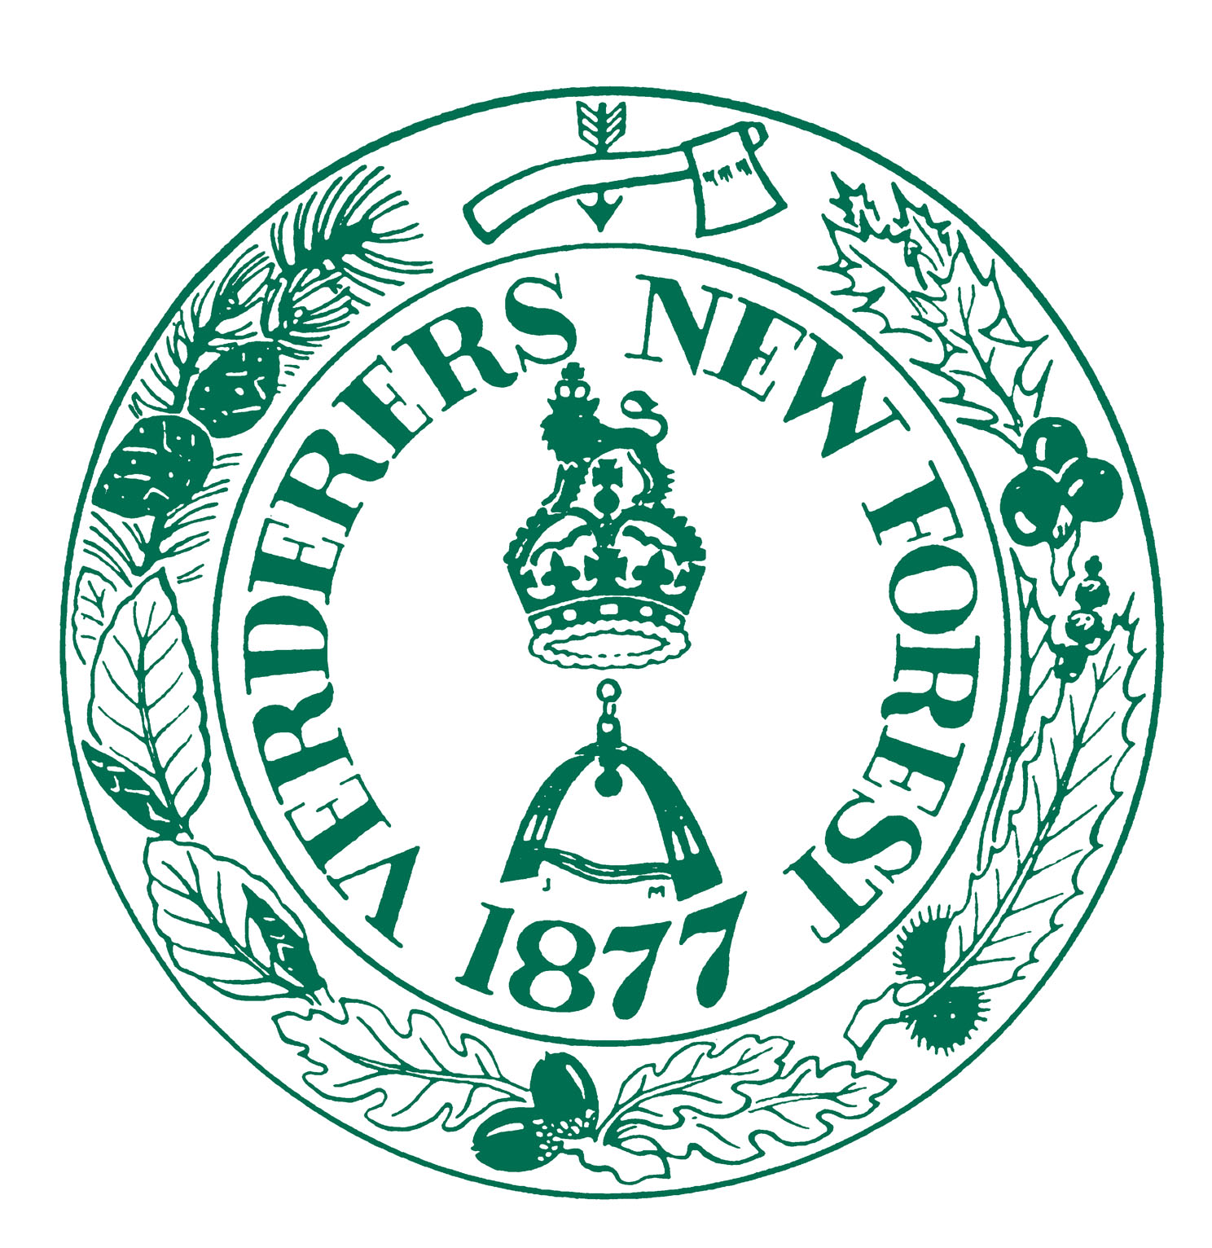  Official Verderer  Edward Heron | Verderers of the New Forest  The King’s House  Lyndhurst  Hampshire  SO43 7NH  Telephone: 023 8028 2052  Fax: 023 8028 3101  E-mail: enquiries@verderers.org.uk

PRIVACY NOTICE March 2024
Dear Commoner

The role of the Verderers of the New Forest is to regulate commoning and development on the open wastes of the New Forest

To administer the New Forest's unique agricultural commoning practices;
To conserve its traditional landscape, wildlife and aesthetic character, including its flora and fauna peacefulness, natural beauty and cultural heritage;
To safeguard a viable future for commoning upon which the foregoing depends.

The Verderers derive their offices, powers and responsibilities from the 1877 New Forest Act and subsequent legislation and therefore have a lawful basis for processing your personal data under Article 6 of the General Data Protection Regulation (GDPR) “Public Task: the processing is necessary for you to perform a task in the public interest or for your official functions, and the task or function has a clear basis in law.”

To enable us to fulfil our duties we need to retain personal details about yourselves your livestock and your holding. This information is securely held in a database accessible only to the Verderers and their employees. Paper records/forms are held in secure storage whilst current and archived in a secure environment thereafter.

We process your information for the following reasons;
Marking Fee Register
New Forest Brand Database
Verderers Election
Verderers Grazing Scheme/ Welfare Scheme/ Small Grant Scheme
Verderers Stallion Scheme
TB Test Certificate (TB52)

We work in conjunction with the Forestry Commission (which manages the Forest on behalf of the Crown), Natural England, and with owners of other areas of common land within the Forest, such as the National Trust and we may share your details with these organisations.
Your details may also be shared with other organisations because of animal welfare legislations – Animal & Plant Health Agency, DEFRA, Rural Payment Agency, Police, RSPCA and Ministry Appointed Veterinarians.
We also periodically send you newsletters and emails from ourselves, the Commoners Defence Association, the New Forest Land Advice Service and the New Forest National Park Authority containing advice or information that is relevant to you. The New Forest Pony Breeding & Cattle Society is also supplied with details of brand ownership for the Stud Book.

Please tick the relevant box on your VGS application form 2024

Web: www.verderers.org.uk E-mail: enquiries@verderers.org.uk

